Mechanical Overview

Year: 2019 Semester: Fall Team: 10 Project: Gesture Controlled Remote for Smart Home

Creation Date: _______9/20/2019_______________ Last Modified: March 3, 2015

Author: ____Wan Hsuan Lo_____________________________ Email: __________lo51@purdue.edu___________________

Assignment Evaluation:

|  |  |  |  |  |
| --- | --- | --- | --- | --- |
| **Item** | **Score (0-5)** | **Weight** | **Points** | **Notes** |
| **Assignment-Specific Items** | | | | |
| **Commercial Packaging Analysis 1** | 5 | x2 | 10 |  |
| **Commercial Packaging Analysis 2** | 5 | x2 | 10 |  |
| **CAD Model Illustrations** | 4.5 | x4 | 18 |  |
| **Project Packaging Specifications** | 5 | x2 | 10 |  |
| **PCB Footprint Layout** | 4 | x2 | 8 |  |
| **Writing-Specific Items** | | | | |
| **Spelling and Grammar** | 4.5 | x2 | 9 |  |
| **Formatting and Citations** | 5 | x1 | 5 |  |
| **Figures and Graphs** | 5 | x2 | 10 |  |
| **Technical Writing Style** | 4.5 | x3 | 13.5 |  |
| **Total Score** | 93.5 | | |  |

5: Excellent 4: Good 3: Acceptable 2: Poor 1: Very Poor 0: Not attempted

Comments:

*Comments from the grader will be inserted here.*

1. Commercial Product Packaging

*Provide analysis of at least two commercial products that are similar to your project. For each example, provide an illustration and description of packaging used. Discuss the positive and negative aspects of the product’s packaging, aspects of the commercial product’s packaging you plan to adapt and how the packaging design of your prototype will differentiate itself from the product in question*

* 1. Product #1

*Analysis of Product #1*

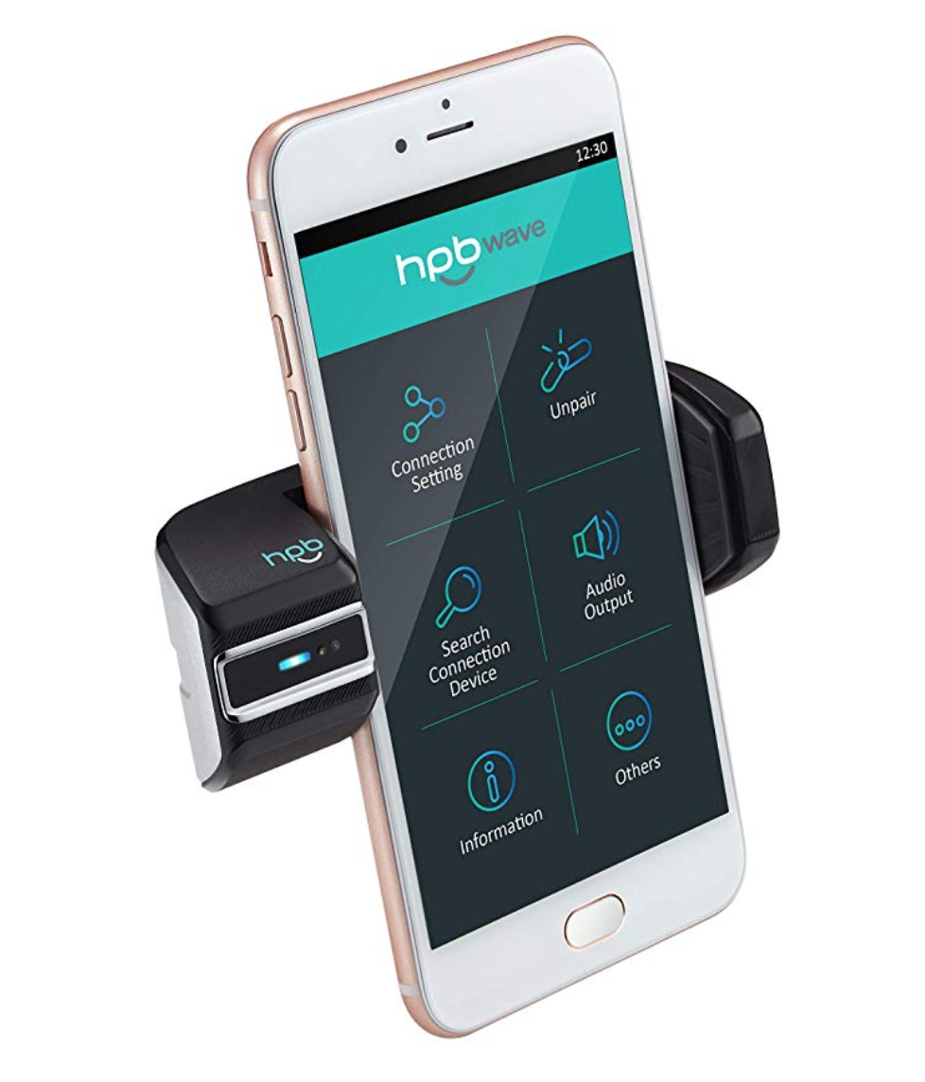

*Figure 1: Packaging for Product #1*

[1] The HPB Wave 11 is a gesture-control car mount. With the gesture sensor and gesture response LED on the left side of the car mount, it reads user’s gestures, converts the gestures to the specific commands, and sends them to the smart phone on the car mount. The gesture-control car mount is powered on by the automobile’s power outlet using the micro USB cable. The detection distance ranges from 5cm to 10cm and 42 degrees vertical and horizontal from the center of the sensor. The power input is DC 5V and 1.5A. The product displays the current status by flashing the blue LED 3 times for detection activation and turning on the blue LED for power on.

One of the use cases would be hand going clockwise/counterclockwise direction to volume up/down the speaker in the car [3]. The gesture control definitely allows drivers to access their smart phone without actually looking at the screen while driving. However, despite its conveniences, picking up phone calls and adjusting volumes, for most of the smart phones on the market, can also be done in a split second. Using HPB Wave 11 The product is surely convenient, but it is only slightly more convenient.

Our project is using battery instead of micro USB cable. We are planning on making it portable. For the sensor, we have similar detection distance except that we are placing the sensor in the middle of our model. In terms of functionality, both our project and the HPB Wave 11 are very similar. We are also aiming for using gestures to control devices. The only difference is that the HPB Wave 11 is sending all the instructions to a smart phone and we are sending messages to different smart home devices based on users’ requests.

* 1. Product #2

*Analysis of Product #2*

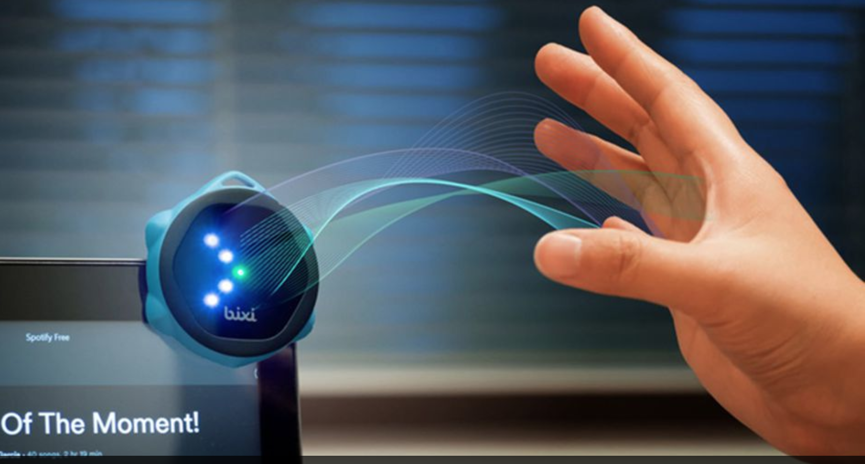

*Figure 2: Packaging for Product #2*

[2] The product Bixi is a device that implements gesture recognition to control smart home devices, GoPro, or other electronic devices. It connects via Bluetooth to a smartphone, tablet, or computers. [4] Using the Bixi App(IOS or Android), you can configure the Apps or connected devices you want to control. Each gesture matches a specific command on the connected device. Bixi uses a time-of-flight based optical sensors with milli-meter level precision. Bixi’s battery can last about a month and more on a single charge lasting 1-2 hours. Bixi also has its own IFTTT channel that allows users to connect Bixi with their devices.

The device can be mounted on a bicycle and connected to a GoPro. Whenever a biker wants to use GoPro to record he or she can just make a hand gesture and Bixi will turn on GoPro and start recording. The device is small and light which is easy to carry around. The battery life is also very impressive. The ability to last about a month and more is great for a portable device.

Our project is also aiming to achieve similar results. However, we have also added an LCD to show the current status, connected device and instruction, so that the user can confirm that the device has successfully read his or her gesture and delivered to the designated device.

3.0 Sources Cited

*Throughout this and other papers, use of the IEEE citation style should be used. Use of embedded hyperlinks for all web-based sources is required. A reference to the IEEE citation style format is provided* [*here*](http://www.ieee.org/documents/ieeecitationref.pdf)*.*

[1] (2019). HPB Wave 11 Hand Gesture Recognition Mobile Phone Controller. [Online]. Available:

<https://www.amazon.com/Gesture-Recognition-Mobile-Phone-Controller/dp/B07KC67DH7/ref=pd_day0_hl_107_1/132-7731098-4695808?_encoding=UTF8&pd_rd_i=B07KC67DH7&pd_rd_r=eb9e7976-f2dc-4da7-af1d-9b9b3a616fd2&pd_rd_w=79zwZ&pd_rd_wg=GnBLC&pf_rd_p=cd872437-0036-44da-b76a-718df210c36e&pf_rd_r=VSEMXN8K2P82X7GTNXMF&psc=1&refRID=VSEMXN8K2P82X7GTNXMF>

[2] (2018). Control Any Smart Device, Simply by Waving at It. [Online]. Available:

<https://mashable.com/2018/05/05/bixi-touch-free-smart-controller/>

[3] (2019). HPBWAVE11. [Online]. Available:

<http://www.hpbhitech.com/product-11.html>

[4] (2016). Bixi: Gesture Control Any Device by Simply Waving. [Online]. Available: <https://www.kickstarter.com/projects/1860920533/bixi-control-any-smart-device-by-simply-waving-you/faqs>

Appendix 1: CAD Model Illustrations

*Provide relevant screenshots of your product packaging CAD model. Be sure to include relevant dimensions as well as units/scale*

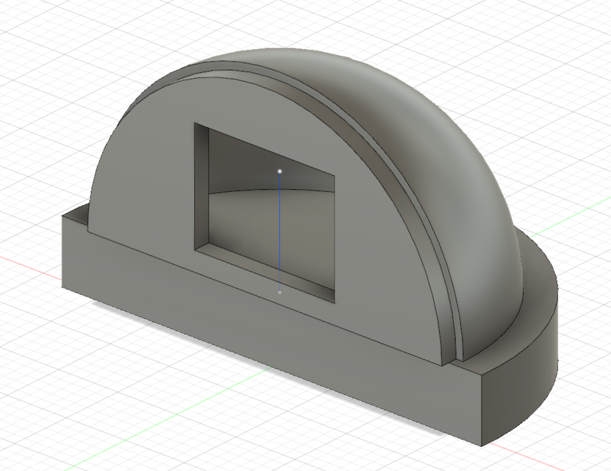

Figure 1. CAD Model for the device package

Base: 7in diameter, 1in thickness

Dome: 6.2inch diameter

space for LCD display: 2.8 diagonal

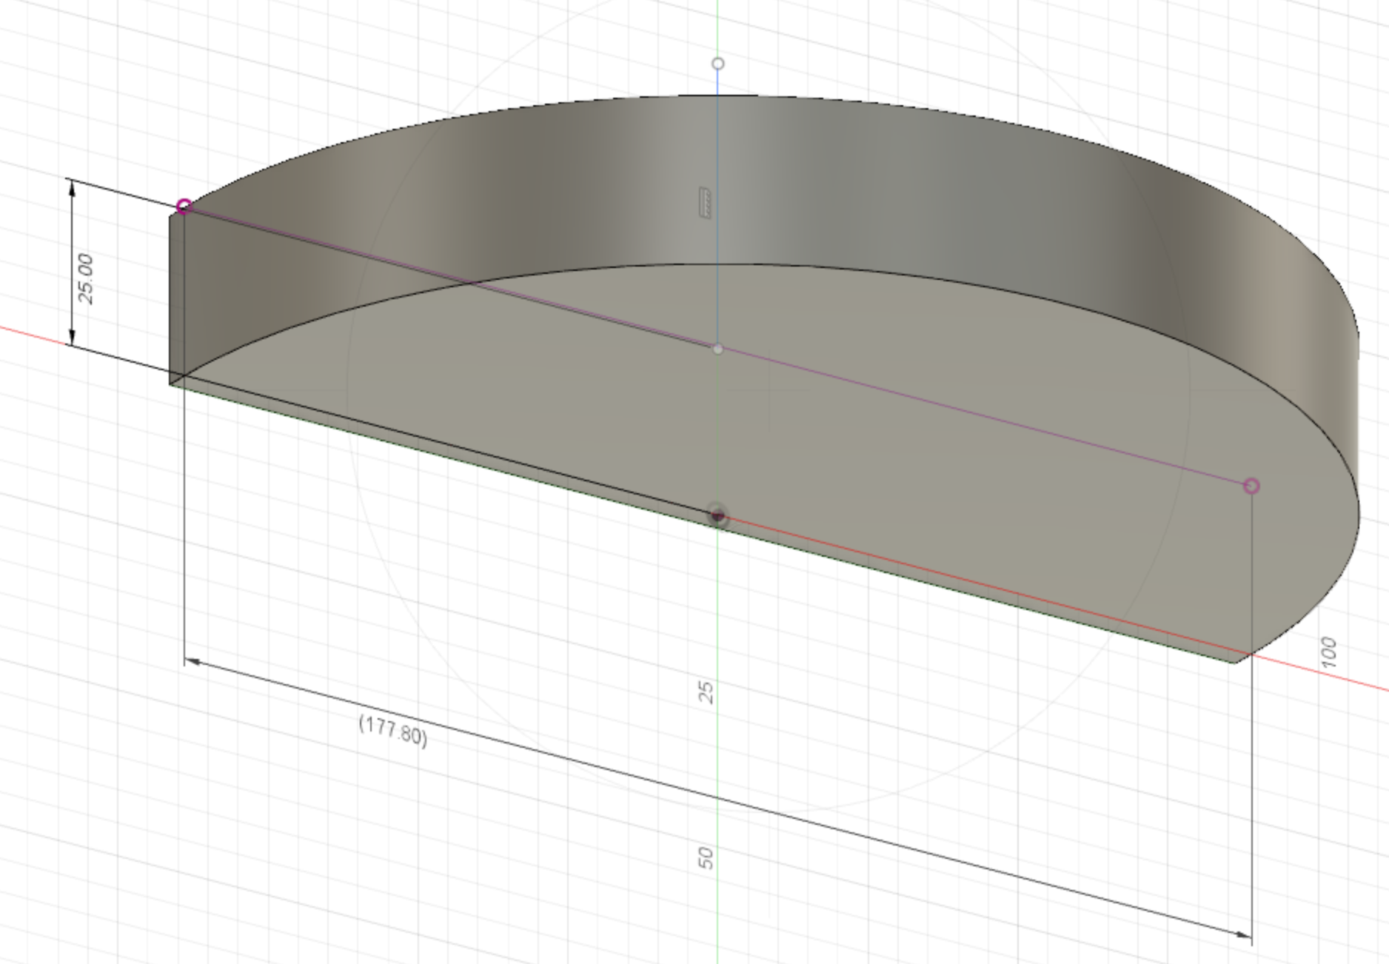

*Figure 2 . Base Model with dimensions (in mm)*

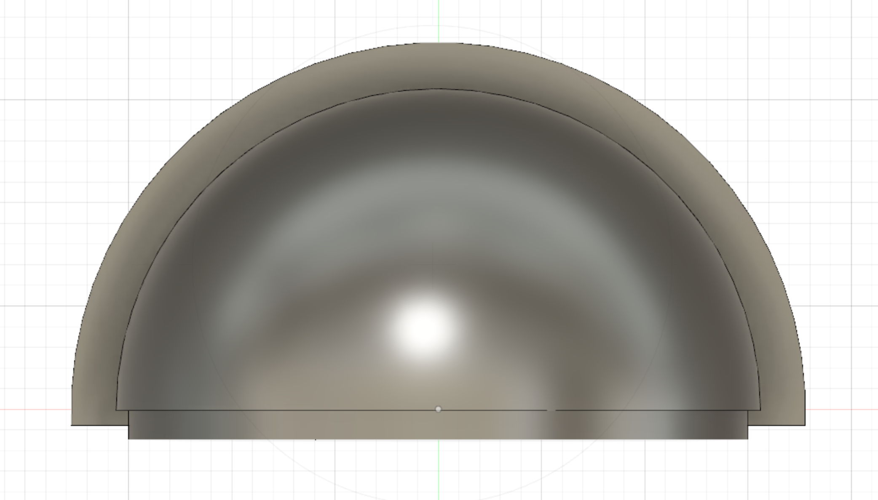

Figure 3. Top view of device package

Appendix 2: Project Packaging Specifications

*Include a table of project packaging specifications here. Include a materials list, tooling requirements, estimated weight, estimated unit cost, and other relevant specifications.*

|  |  |  |  |
| --- | --- | --- | --- |
| Material | Quantity | Weight | Cost |
| Dark Glass Acrylics Sheet | 1 | 50g | 20 |
| Dark Clear Acrylic Dome | 1 | 90g | 35 |
| Screws | 5 | 20g | 4.99 |
| ABS Plastic | 1 | 50g | 9.99 |
| Total | 8 | 210g | 69.98 |

|  |  |
| --- | --- |
| Tooling | Estimated Cost |
| 3D-printing | Free with Artisan Fabrication Lab(AFL) |
| Screwdriver | Free |
| Hot Glue | Free |

Estimated packaging weight: 210g

Estimated packaging costs: $69.98

Appendix 3: PCB Footprint Layout

*Provide a “rough sketch” of your PCB layout, including board dimensions, component footprint choices, and relative location of major components chosen; include relevant dimensions and area estimates for your PCB.*

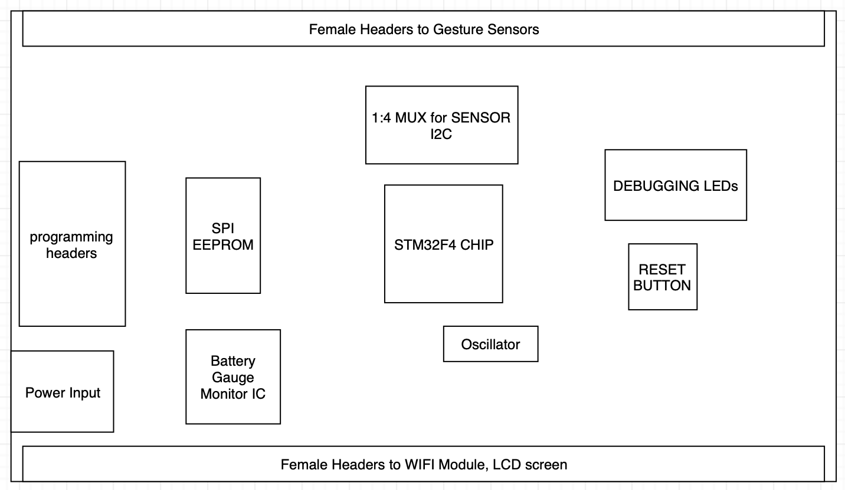

Figure 4. Microcontroller board

Board Dimension: 70mm * 90mm

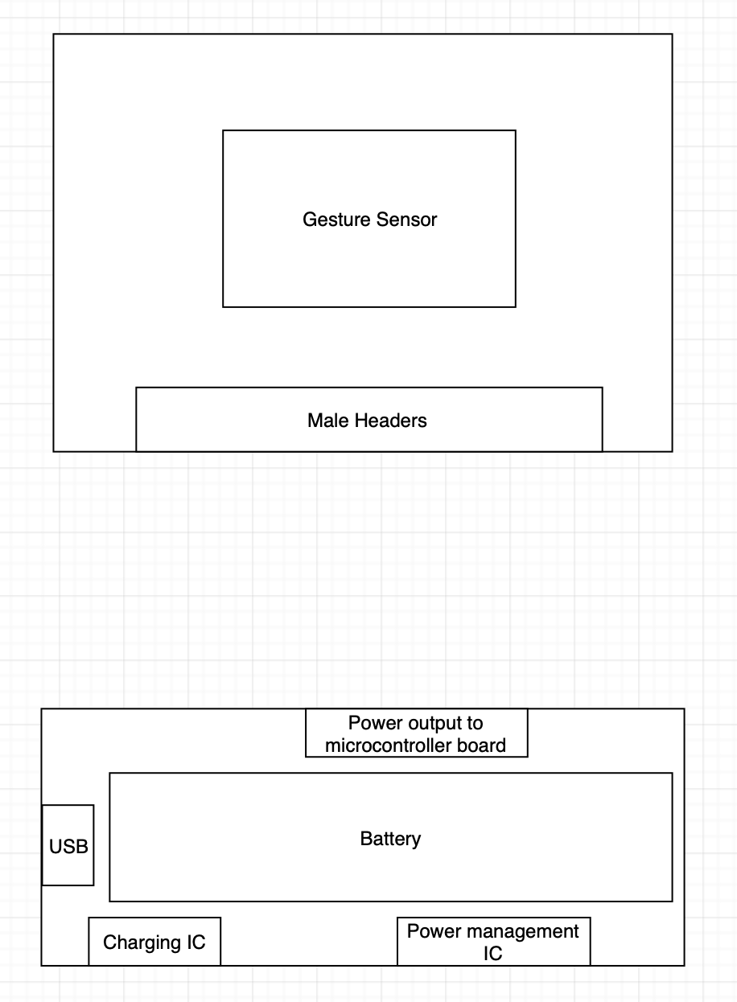

Sensor Board Dimension:

Battery Board Dimension: roughly 25 mm * 90 mm